# Document Purpose and Audience

Any document anywhere should tell us 2 things: (1) what this document is and (2) who is expected to read it.

Write in simple notes: What is this document?

List the target audience to read this document (e.g. CEO? Project Manager? Customer...?)

# Introduction

## Software Purpose

## Software Scope

· Any software could have too many components / Major features .. but we should implement specific things...this is the scope

· In simple points, what is the software scope (focus on components / Major features, not tiny things)

## **Definitions, acronyms, and abbreviations**

· In a table, list all needed ones. Consider the audience

· Think as follows: Document has abbreviation ATM..IFF audience doesn’t know it, let’s clarify it.

# Requirements

## Functional Requirements Users can classify their document by uploading it as a text file or writing it directly. System takes the file and parses its text to sentences, paragraphs and words. System uses a classifier or multi-classifiers to classify the document. System output class or multi-classes of the document.

## Non Functional Requirements

|  |  |
| --- | --- |
| **Non-functional**  **Requirement** | **Details** |
| **Performance** | Calculation time and response time should be as little as possible, because one of the software’s features is timesaving.  Any interface between a user and the automated system shall have a maximum response time of 5 seconds unless noted by an exception below(exceptional is optional till now). |
| **Usability** | The system should be easy to use. The user should reach the summarized text with one button press if possible. And one of the software’s features is timesaving.  The system also should be user friendly. |
| **Reliability** | This software will be developed with machine learning, feature engineering and deep learning techniques. So, in this step there is no certain reliable percentage that is measurable. |
| **Scalability** | Analytics platforms must be applicable to a machine or facility of any size. |

-

# System Models

## Use Case Model

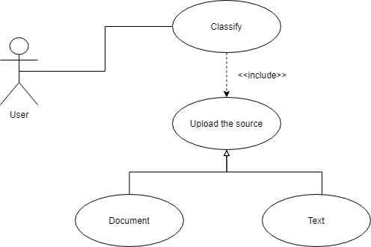

## Use Case Tables

|  |  |  |
| --- | --- | --- |
| Use Case ID: | 1 | |
| Use Case Name: | Upload and classify a Document | |
| Actors: | User | |
| Pre-conditions: | Document Should be text based ******* | |
| Post-conditions: | The document is ready to be classified | |
| Flow of events: | **User Action** | **System Action** |
| 1- User uploads a documents or type a text |  |
|  | 2- System verifies user input |
| 3- User request to classify the document or the input text |  |
|  | 4- System classifies the document or the user input. |
| Exceptions: | **User Action** | **System Action** |
| 1- User uploads a non-text input. |  |
|  | 2- Response to user invalid input format. |

## Class Diagram

Login , show history … etc

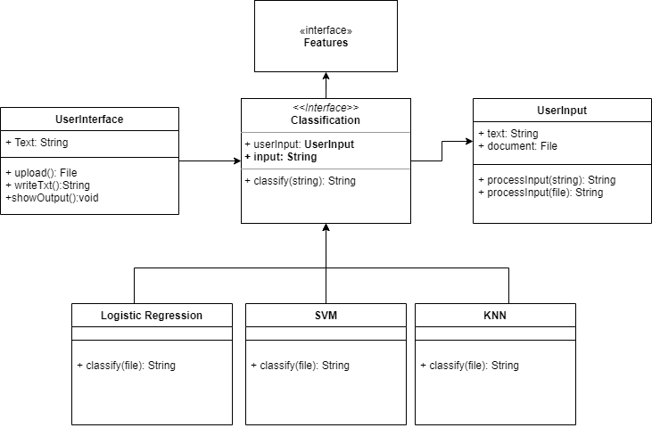

## Sequence Diagram